Training Hosted By:
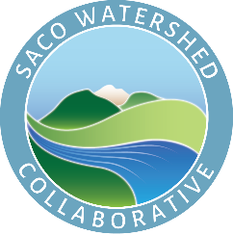
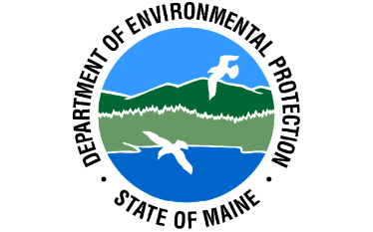
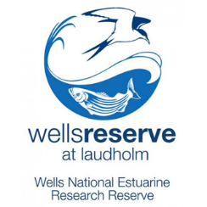

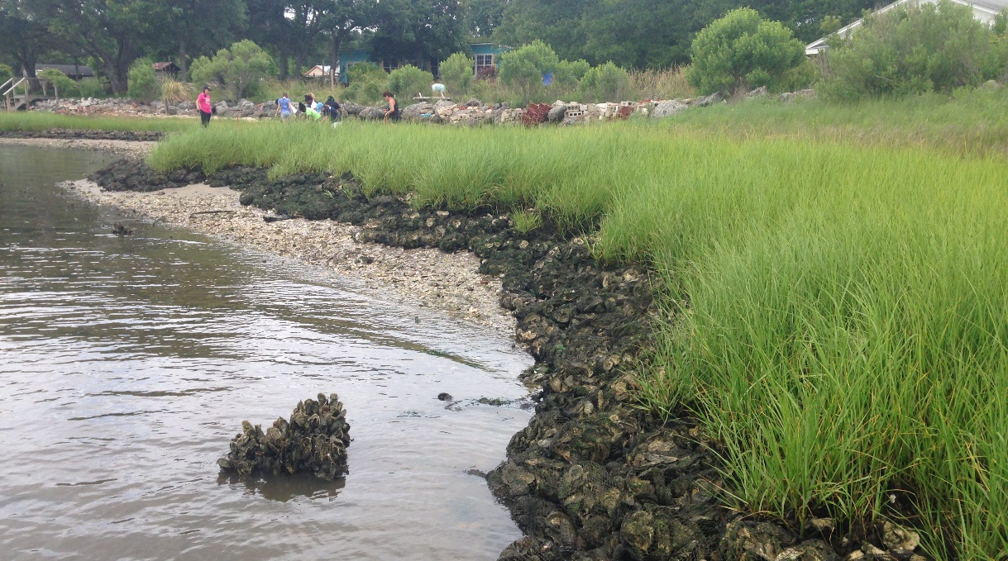
WEBINAR
Coastal Erosion Control and Living Shorelines
Tuesday, June 22, 2021
8:45 AM – 12:00 Noon
Many factors are putting pressure on Maine’s coastal communities. Our long, jagged and heavily developed coastline is increasingly vulnerable to more intense storm surge, increased flooding frequency and devastating erosion. Valuable coastal property has been lost. Action must be taken.

Much of the developed world have relied on rigid coastal defenses for centuries, with very mixed success. In the Netherlands, however, the Dutch have been successfully employing living shoreline techniques for three millennia. Finally, in the United States, there has been a strong shift to emphasis on living shoreline best management practices.

Register for the webinar here: https://www.eventbrite.com/e/coastal-erosion-control-and-living-shorelines-tickets-155964366619

Ticket refunds are available until June 15, 2021.
Course objectives include:

- Understanding the challenges facing Maine’s coastline, including sea level rise, climate change, coastal development and traditional drainage practices.
- Examining traditional erosion and sediment control practices, including seawalls, breakwaters, bulkheads and revetments.
- Exploring living shoreline creation as a method of restoring and protecting coastal ecosystems.
- Reviewing living shoreline best management practices, including dune restoration, nature-based solutions and wave attenuation.
- Evaluating lessons learned by examining relevant living shoreline and coastal erosion control case studies.

Agenda

8:30 AM – 8:40 AM Welcome Christine Feurt, Ph. D.
Coastal Training Program Director
Wells National Estuarine Research Reserve
Wells, Maine

8:40 – 8:45 AM Opening Remarks John MacLaine
Non-Point Source Training Center Coordinator
Maine Department of Environmental Protection
Augusta, ME

8:45 – 10:15 AM Education Program Part I

10:15 – 10:30 AM Break

10:30 AM – 12 PM Education Program Part II

12:00 PM Adjourn

Trainer:
Peter M. Hanrahan, CPESC; Principal
Hanrahan Environmental, LLC
16 Alora Drive
Topsham, ME 04086
(207) 576-9215
hanrahanenvironmental@yahoo.com

Peter Hanrahan is a Certified Professional in Erosion and Sediment Control, and has more than 43 years of industry experience. Peter has made presentations nationally and in Canada, Taiwan and the Dominican Republic for many organizations, including the International Erosion Control Association, Land Improvement Contractors of America, the Geotechnical Fabrics Institute, and the American Water Works Association.

His articles have been published in many magazines, including Erosion Control, Land & Water, Geosynthetics, and Landscape Architect & Specifier News.

Continuing Education Information
All attendees will receive certificates for Three (3.0) Professional Development Hours.
The course qualifies for Three (3.0) Continuing Education Hours for the Maine Department of Environmental Protection’s Contractor Erosion Control Certification Program.
The course qualifies for Three (3.0) Continuing Education for all Envirocert International® certification holders.
The course qualifies for three (3.0) Continuing Education Hours for the Maine Department of Environmental Protection’s Stormwater Inspector’s Certification Program.
The course qualifies for three (3.0) Continuing Education Hours for the Maine Department of Environmental Protection’s Stream Crossing Certification Program.

