Maine New England Cottontail Restoration Coordinator
The Coordinator provides technical assistance and project oversight for restoration activities for New England cottontail (NEC). The Coordinator initiates landowner contacts, conducts habitat assessments, and works with key partners to implement conservation measures. Interactions with landowners include matching landowners to agencies that provide project funding and technical assistance for NEC restoration projects, and helping landowners plan, implement, and monitor these projects. When desirable, the Coordinator assists landowners with the enrollment process for the Candidate Conservation Agreement with Assurances (CCAA) program and assesses enrolled properties for compliance.

The Coordinator provides technical assistance in identifying high priority areas for NEC restoration activities and assists with identifying properties for acquisition. This includes conducting surveys for NEC, using GIS to map and identify landscape features, researching state and federal land-use regulations, and developing management plans. The Coordinator chairs Maine’s NEC Land Management Group, which includes leading meetings, updating the group on the status of projects, and resolving issues that arise within a project.

The Coordinator works with the Maine Department of Inland Fisheries (MDIFW) and Wildlife to ensure NEC management is conducted according to Rangewide and Maine specific management objectives and tracks progress in implementing these objectives. The Coordinator assists with preparing annual progress reports for the NEC Rangewide Conservation Initiative, and may present these reports to the Rangewide NEC Technical or Executive Committees. The Coordinator assists Maine’s representative on Rangewide NEC Technical Committee and may serve as Maine’s acting Technical Committee Representative in the absence of the MDIFW representative. The Coordinator works with partners to complete reporting and match tracking requirements for grants.

Salary/Housing:
This position will be an employee of the Wells National Estuarine Research Reserve, but will be based at Rachel Carson National Wildlife Refuge (Wells, ME). The position is supported by a National Fish and Wildlife Foundation grant and funds from the Maine Department of Inland Fisheries and Wildlife. The position is fully funded for 2.5 years and may be renewed if additional funding is secured. Salary: $58,000 to $63,338 annually, depending on experience. The position accrues 3 weeks of vacation per year, and is granted 12 paid holidays and accrued sick leave (if needed). There are no other benefits (e.g., health/dental insurances) associated with this position. Government housing may be available at locally competitive rates or the selectee can provide their own housing within commuting distance of Wells, ME.

Qualifications and Requirements:

- Demonstrated ability to work with people from a variety of backgrounds. Experience in working with landowners or volunteers is a plus.

- A willingness to motivate and inspire private, nonprofit, and public landowners to plan, organize, and implement wildlife and habitat management plans.

- Ability to track nonfederal match for grants and the ability to maintain categorical financial records and billable hours.

- Demonstrated skilled in person-to-person communication and public speaking and writing.

- Knowledge of and experience with implementing habitat restoration practices including seeding, planting, forest management, and invasive plant control.

- Ability to evaluate, rank and prioritize projects; demonstrated ability to manage multiple projects at once.

- Skilled in the use of ArcGIS, GPS, plant survey techniques, and wildlife survey techniques.

For additional information contact Cory Stearns or Kate O’Brien at the information below:

Cory Stearns
Small Mammal Biologist
Maine Dept. of Inland Fisheries and Wildlife
(207) 592-1782
Cory.r.stearns@maine.gov

Kate O’Brien
Refuge Biologist
Rachel Carson National Wildlife Refuge
(207) 646-9226
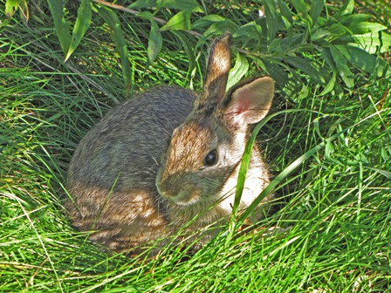
Kate_obrien@fws.gov

To apply, please submit a resume, cover letter and a written statement addressing each qualification by e-mail to Cory Stearns at: cory.r.stearns@maine.gov. The application deadline is September 24, 2021.

