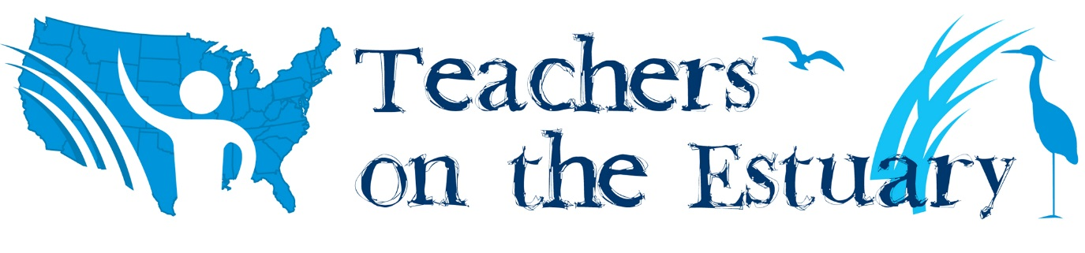
Wells National Estuarine Research Reserve
Teachers on the Estuary (TOTE) Workshop Agenda: 16 contact hours
August 17 and 18, 2021

Tuesday, August 17
High tide: 6:52am Low tide: 12:46pm

7:45am Breakfast snacks & drinks will be available
8-8:30am Introductions
8:30-9:30am Estuary walk
9:30-10:30am Nature journaling, part I
10:30-10:45 Break
10:45am-12:30pm Marine invasive species monitoring at Wells Harbor
12:30-1pm Lunch
1:00-3:45pm Water quality monitoring & seining at the marsh
3:45-4pm Evaluations

Wednesday, August 18
High tide: 7:59am Low tide: 1:51pm

7:45am Breakfast snacks & drinks will be available
8:00-8:30am Day one reflections/discussion
8:30-11:15am Kayaking on the Little River Estuary
11:15-11:30am Break
11:30am-12:30pm Sea level rise panel discussion
12:30-1pm Lunch
1-2:30pm Sea level rise activity at the marsh
2:30-3:15pm Nature journaling, part II
3:15-3:45pm Discussion on classroom applicability
3:45-4pm Evaluations

